**Making JSON Pretty with Visual Studio Code** Jim Allison 2/27/19

When Microsoft SQL Server creates JSON output with the FOR JSON clause, the results are returned as valid JSON but that JSON text is in a compact and not very pretty form. At this time there seems to be no FOR JSON syntax that will produce JSON output in the more human readable formatting known as pretty JSON. Fortunately there is a free cross platform application from Microsoft called Visual Studio Code which can reformat the compact JSON output into easily readable pretty JSON with just a few mouse clicks.

Visual Studio Code is a great programmer oriented text editor available for Mac OS and Windows:

<https://code.visualstudio.com/download>

How to prettify JSON with Visual Studio Code

1. Start Visual Studio Code and use the File/Open menu choice to locate and open your JSON file. If your JSON is in compact form, it will look something like this:

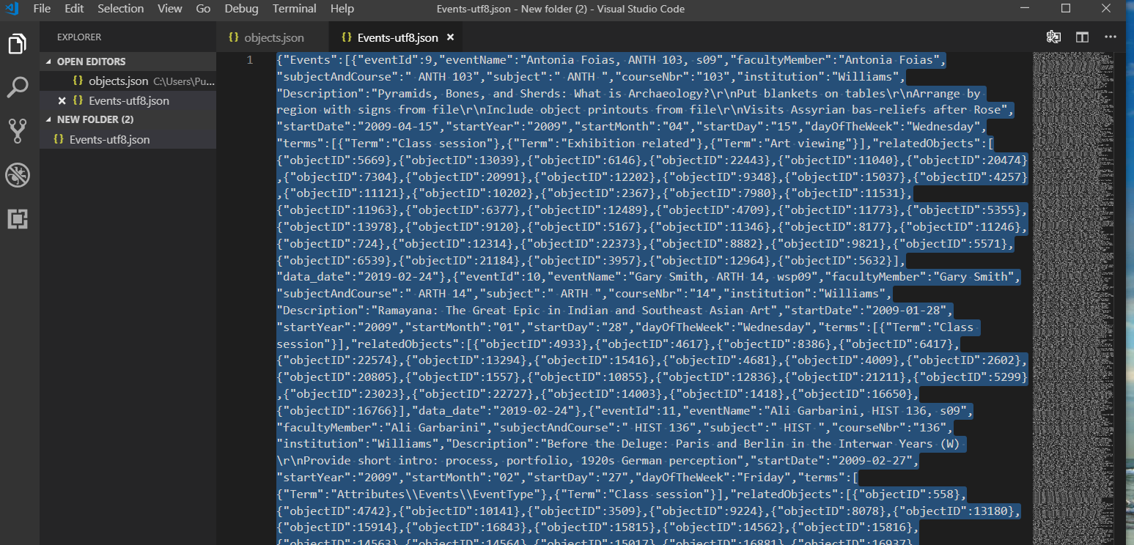

1. From the Selection Menu choose Select All

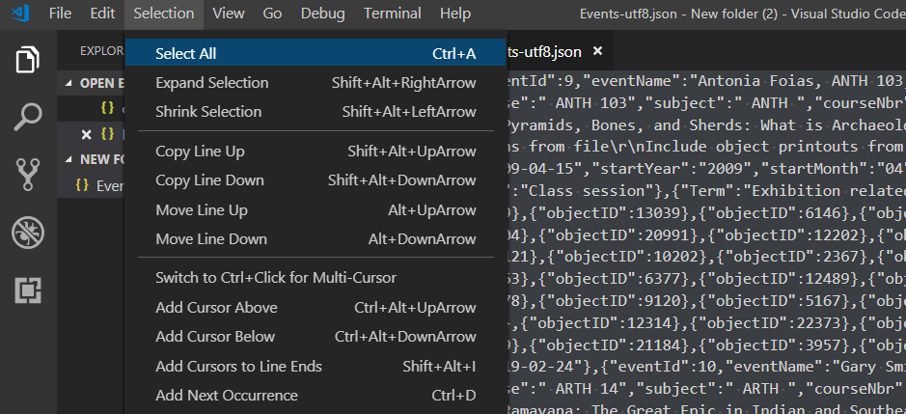

1. Right click on the selected text and choose Format Selection from the popup window

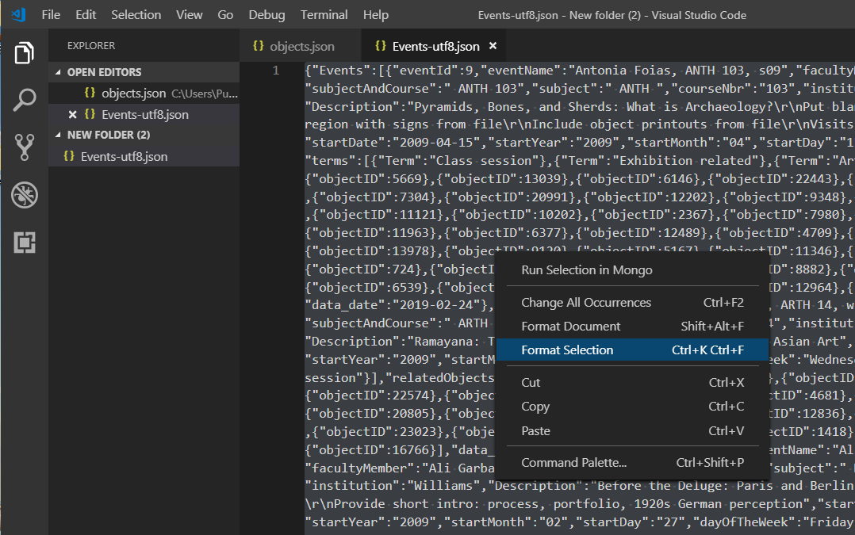

Here is what the pretty JSON looks like

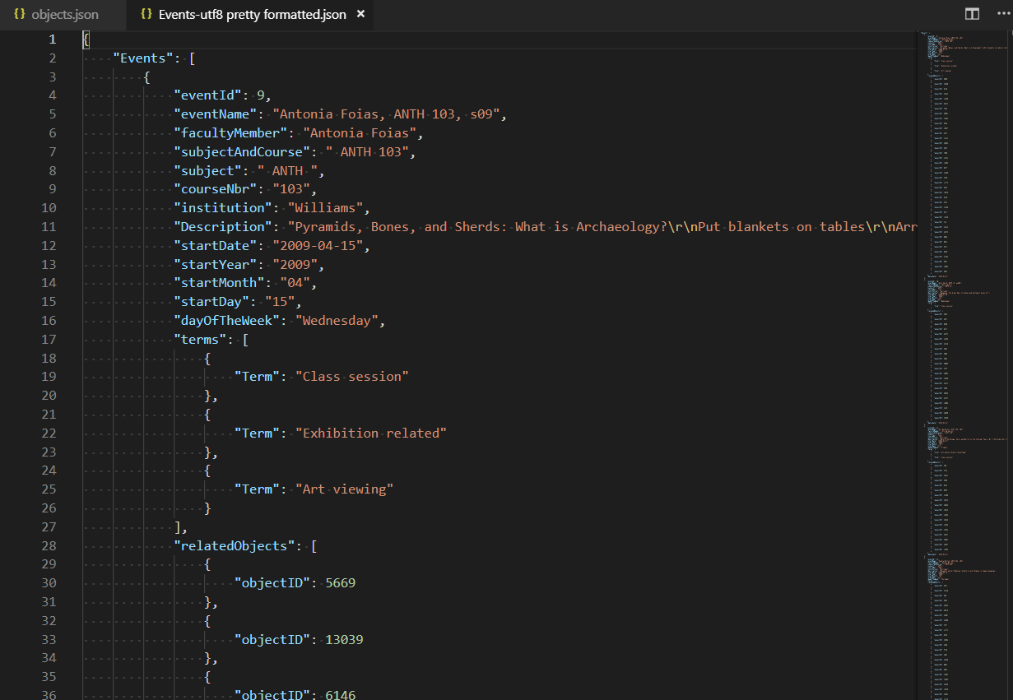

1. Choose Save or Save As from the File Menu to keep your pretty formatted version.